CS5551 Advanced Software Engineering
Project Plan

Project Title: Pick me up

PG6 (SG14 and SG15)
Ponnada, Rahul(Class ID-39)
Ghanta, Surya Prabha(Class ID-19)
Tummala, Anvesh(Class ID-48)
Anumolu, Satish Chowdary(Class ID-2)

Project Plan
- Introduction:

Currently there is no application for making the process of airport pick up easy. At the start of every semester, we traditionally follow the students filling spreadsheets and manually assigning the volunteers. There are times a volunteer has to wait more than 3 hours in Airport because of flight delays. Therefore, we thought of an application that connects the students, volunteers and make the pickup process easy.

II. Project Goal and Objectives (revised)
- Overall goal :
The main goal of this project is to build an android-based application for the airport pick up of the students coming for a university. It will allow assigning volunteers to pick students and providing temporary accommodation if required.

- Specific objectives (problem statement)
The specific objectives of the project include providing the common place to meet the volunteers and new coming students and to make the process of airport pickup easy. In addition, this application provides climate details and provides easy access of navigation to the respective destinations.

- Significance
We feel there is a real need of this application for all universities at the start of every semester. This application makes the process of pickup so easy. As the new coming students do not make calls during flight journey, this application will help to be in contact to volunteers.

III. Project Background and Related Work

We have come up with this project idea as we have seen the difficulty in the normal process of creating the excel sheets and updating manually. When we look for an application that help this process, we have not found any related applications.

IV. Proposed System
1) Requirement Specification

Functional requirements:

- New students will create an account by entering their personal details like first name, last name, Phone number, email id and password.
- Student will update the travel information if they need a pick up. Travel information includes baggage information, arrival date, flight details and accommodation address details.
- Interested volunteers will register by providing their personal detail like first name, last name, Phone number, address, email id and password along with their available timings.
- Once the new students are registered, system should assign the volunteers based on their available timings.
- Admin should be able to see entire pickup information.
- Volunteers should be able to see his assignee pickups.
- Volunteers should be able to check the flight status all the time.
- Volunteers should be assisted with google maps to navigate to respective addresses provided by the students.
- Students should be able to see the weather information upon the time of their arrival.
- Volunteers and students can tweet or post status in Twitter and Facebook about the application or any related information.

Non-functional requirements:

- The system should assign the volunteers automatically without any redundancy.
- All the validations should be done during the registration of students and volunteers.
- The user interface should be very user friendly and easy navigable.

Technical/business Requirements (prioritized)
System: The system should assign volunteers without any redundancy.
Students: All the users should have the updated information time-to-time.
Admin: Admin should be able to change the assigned volunteers any time.
Volunteers: Volunteers should have the feasibility to change their available timings.

Business Process/Workflow analysis (UML Activity Diagram)

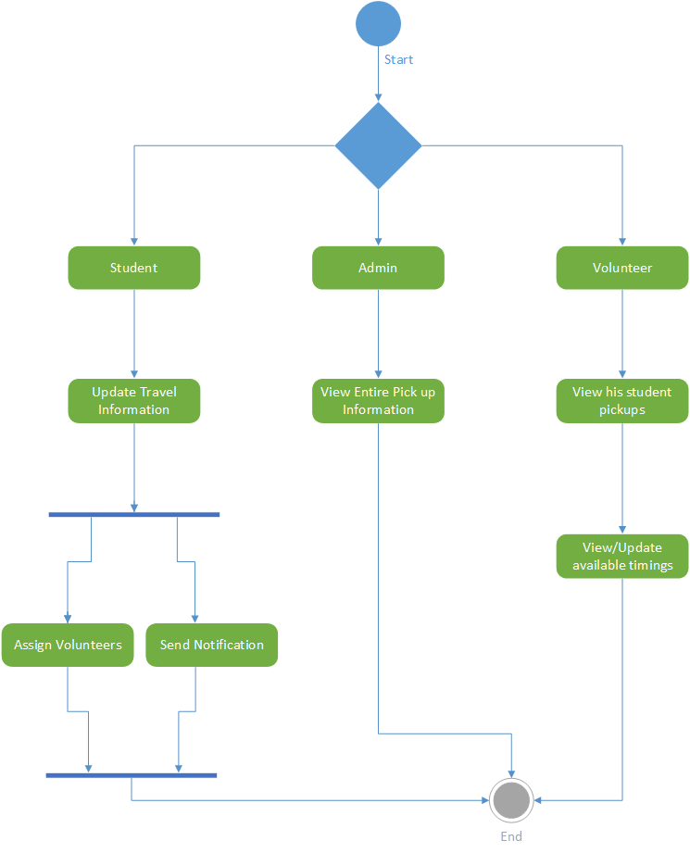

Technological and Architectural requirements

Required technologies are HTML5, JavaScript, and CSS for the user interface. AJAX is also used to get the asynchronous information like weather details and flight status information. Architectural requirements include a layered structure, which will be managing the workflow of the system. We require SQL database to store the information. A collection of web services is required to access data from different sources.

2) Framework Specification: Build an overall system model

- Assumptions and Principles
- The users are assumed to have an Android mobile to use the application.
- Registration is restricted to UMKC students only.
- Methodologies and Algorithms (if any)

- We are using scheduling algorithm to assign volunteers to students based on their availability.
- This algorithm is also responsible for updating the volunteers based on the flight delays or any changes to available timings.

- System Architecture Diagram

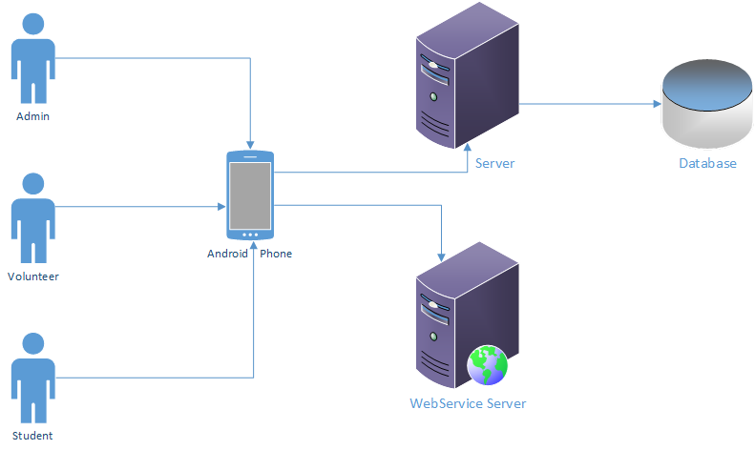

3) System Specification:
- Existing Services:

- Name: Google Maps API.
Description: Used to provide navigation for volunteers from their current location to airport Pickup location and to dropping location.
URL: https://developers.google.com/maps/documentation/javascript/tutorial

- Name: Weather API.
Description: To get weather information.
URL: http://openweathermap.org/api

- Name: Flight Status
Description: To get information about the flight status.
URL: https://developer.flightstats.com/

- Name: Facebook
Description: To post updates on Facebook and for Login.
URL: https://developers.facebook.com/docs

- Name: Twitter
Description: To tweet about their status on twitter.
URL: https://dev.twitter.com/overview/documentation

- Name: Google Cloud Messaging for Android
Description: For notification about assigning volunteers and pickup students.
URL: https://developer.android.com/google/gcm/index.html

- New Services to be built:

- Scheduling the volunteers for pickups: This service provides the scheduling of volunteers for the pickups based on match of available timing of volunteers and the pickup times.
Service Specifications:
Input: The Pickup times of the newly coming students, available timing for volunteers.

Output: An efficient scheduling of volunteers for picking new students.

Exception: If there are no volunteers available for picking a student, the system has to notify admin for assigning a volunteer available at that time.

Class diagram

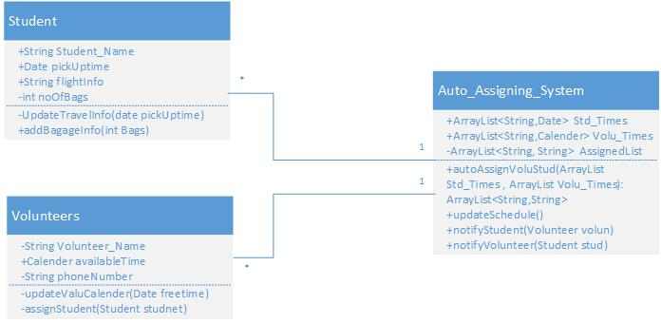

Class diagram for scheduling the volunteers for pickups

Sequence diagram

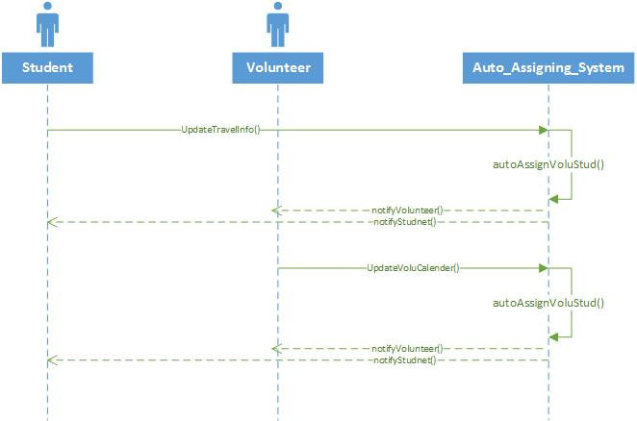

Sequence Diagram for the service of auto schedule

- Design of Mobile Client:

Features: Register, Login, Request_Pickup, Cancel_Request, Navigation
Styles: CSS
Technologies: HTML5
JavaScript
JQuery Mobile
Twitter Bootstrap
Java (Back end)
Database: Microsoft SQL Server 2008
Tools: Android Studio, SQL developer

V. Plan by Services (using ScrumDo)

Schedule for the four different increments
Increment 1:
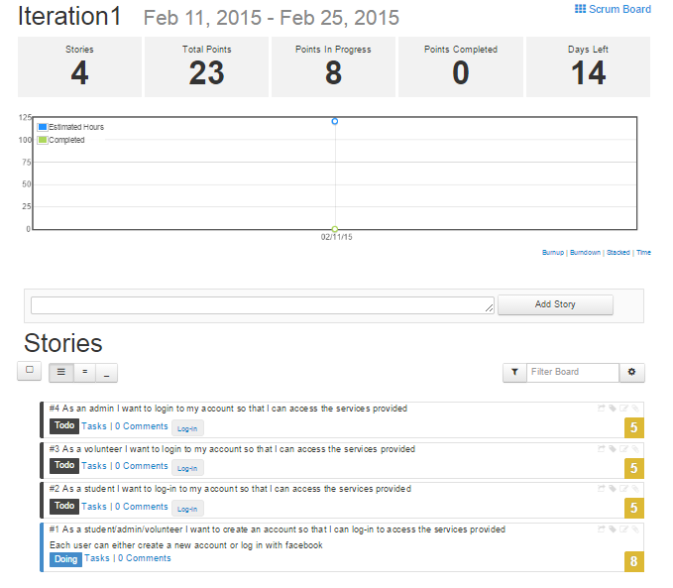

Increment 2:
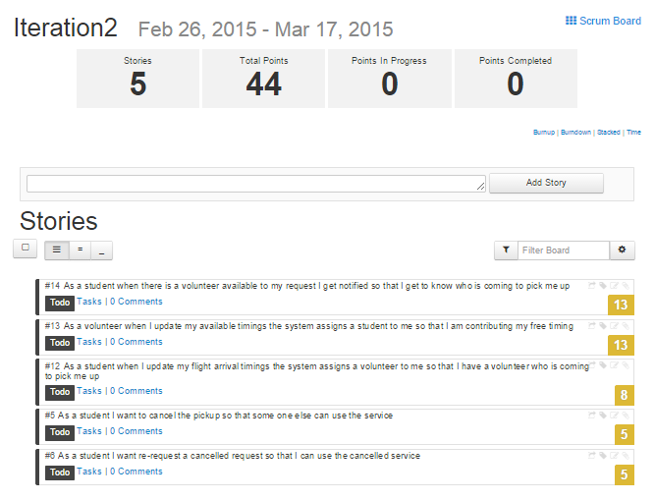
Increment 3:
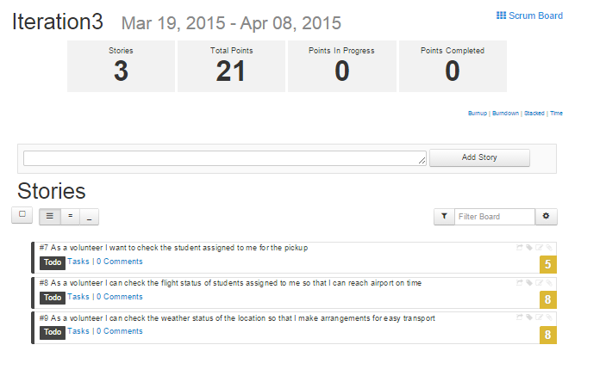

Increment 4:
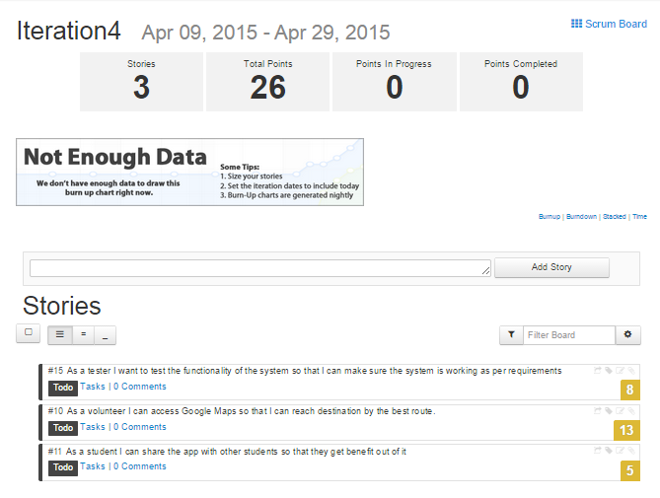

VI. Risk management

Risks in a project should be identified and resolved by using some recovery methods. Minor risks involved in our project are:
- Users may forget their passwords.
- Validity of the volunteers is very important and that is taken care by admin.

VIII. Bibliography
- http://www.w3schools.com/
- https://developer.flightstats.com/api-docs/flightstatus/v2
- https://developers.google.com/maps/documentation/android/
- http://openweathermap.org/api
- https://developer.android.com/training/index.html

